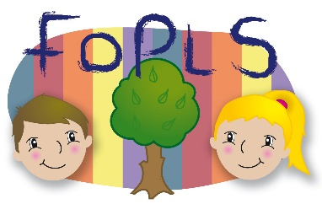 | Friends of Park Lane School  Registered Charity No 1136443
Park Lane School & Nursery, Park Lane, Whittlesey, Peterborough, PE7 1JB

Dear Parents/Carers

As a means to raise additional funds for the school, Friends of Park Lane School & Nursery (FOPLS) will once again hold cake bakes for each individual year group. This is an excellent way for you to contribute towards raising these extra funds for your child’s class so that they are able to purchase additional equipment and resources.

All that we ask is that on the morning of the cake bake, your child brings some cakes into school. These can be homemade or shop bought (in date please and in original packaging). Please do not send cakes with nuts, nut-based or sesame products. They will then be sold to all the children and parents after school. The more cakes that are bought in, the more we can sell and therefore, the more money we can raise for your child’s class.

Reception cake bake will be on Friday 10th May

Cakes will be sold from South Hall at the end of school from 20p each.

We do hope you will support this event and we look forward to seeing you on the day.

Thank you

Lyndsey Brown
Friends of Park Lane School & Nursery

